**Building Roads**

Building roads in Texas takes time. To calculate just how much time will be needed, you must design a program that can figure out the minimum number of months it will take to build all the roads. Some roads will take more time than others to complete, and some roads can only be started once the previous roads leading up to it are complete, and some roads can be worked on at the same time depending on the prerequisite roads.

**Input:** The first line of input contains **T**, the number of test cases. Each test case will be as follows: The first line will be **C** the number of connections and **R**, the number of roads. The next **C** lines contain two space separated integers. They represent the previous road, followed by the next road (which means that the previous road is a prerequisite to beginning the next road). Next, you will have **T**, the time corresponding to each the ***i***-th road. The next line contains **T** space separated integers which represent how many months it will take to complete the ***i***-th road.

**Output:** For each test case, you will first output “CASE #(case number): “ followed by the minimum number of months it would take to complete all the roads.

**Example Input:**

2

2 3

1 3

2 3

3

3 2 5

5 5

1 5

2 5

3 5

3 4

4 5

5

1 2 3 4 5

**Example Output:**

CASE #1: 8

CASE #2: 12

**Explanation:** For the first test case, the timeline of the roads will look like this:

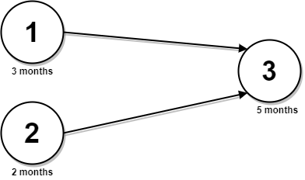

You can start road 1 and 2 at the same time (month 0). And finish them in 3 and 2 months respectively. After those are complete, you can finally start on road 3, which takes 5 months. In total, it took 8 months because the earliest we can start road 3 is at month 3.

For the second test case, the timeline of the roads will look like this:

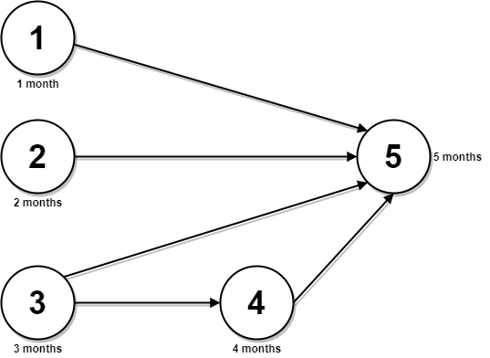

You start working on roads 1, 2, and 3 at month 0. Course 4 can only be started on once course 3 is completed, so 3 + 4 = 7 months so far. After all roads (except 5) are complete, you can finally start on road 5, which takes another 5 months. So 7 + 5 = 12 months in total.